(Approx. 2213 words)

Rational Backup Strategy

By Dick Maybach, Member, Brookdale Computer Users’ Group, NJ

January 2017 issue, BUG Bytes

www.bcug.com

n2nd (at) att.net

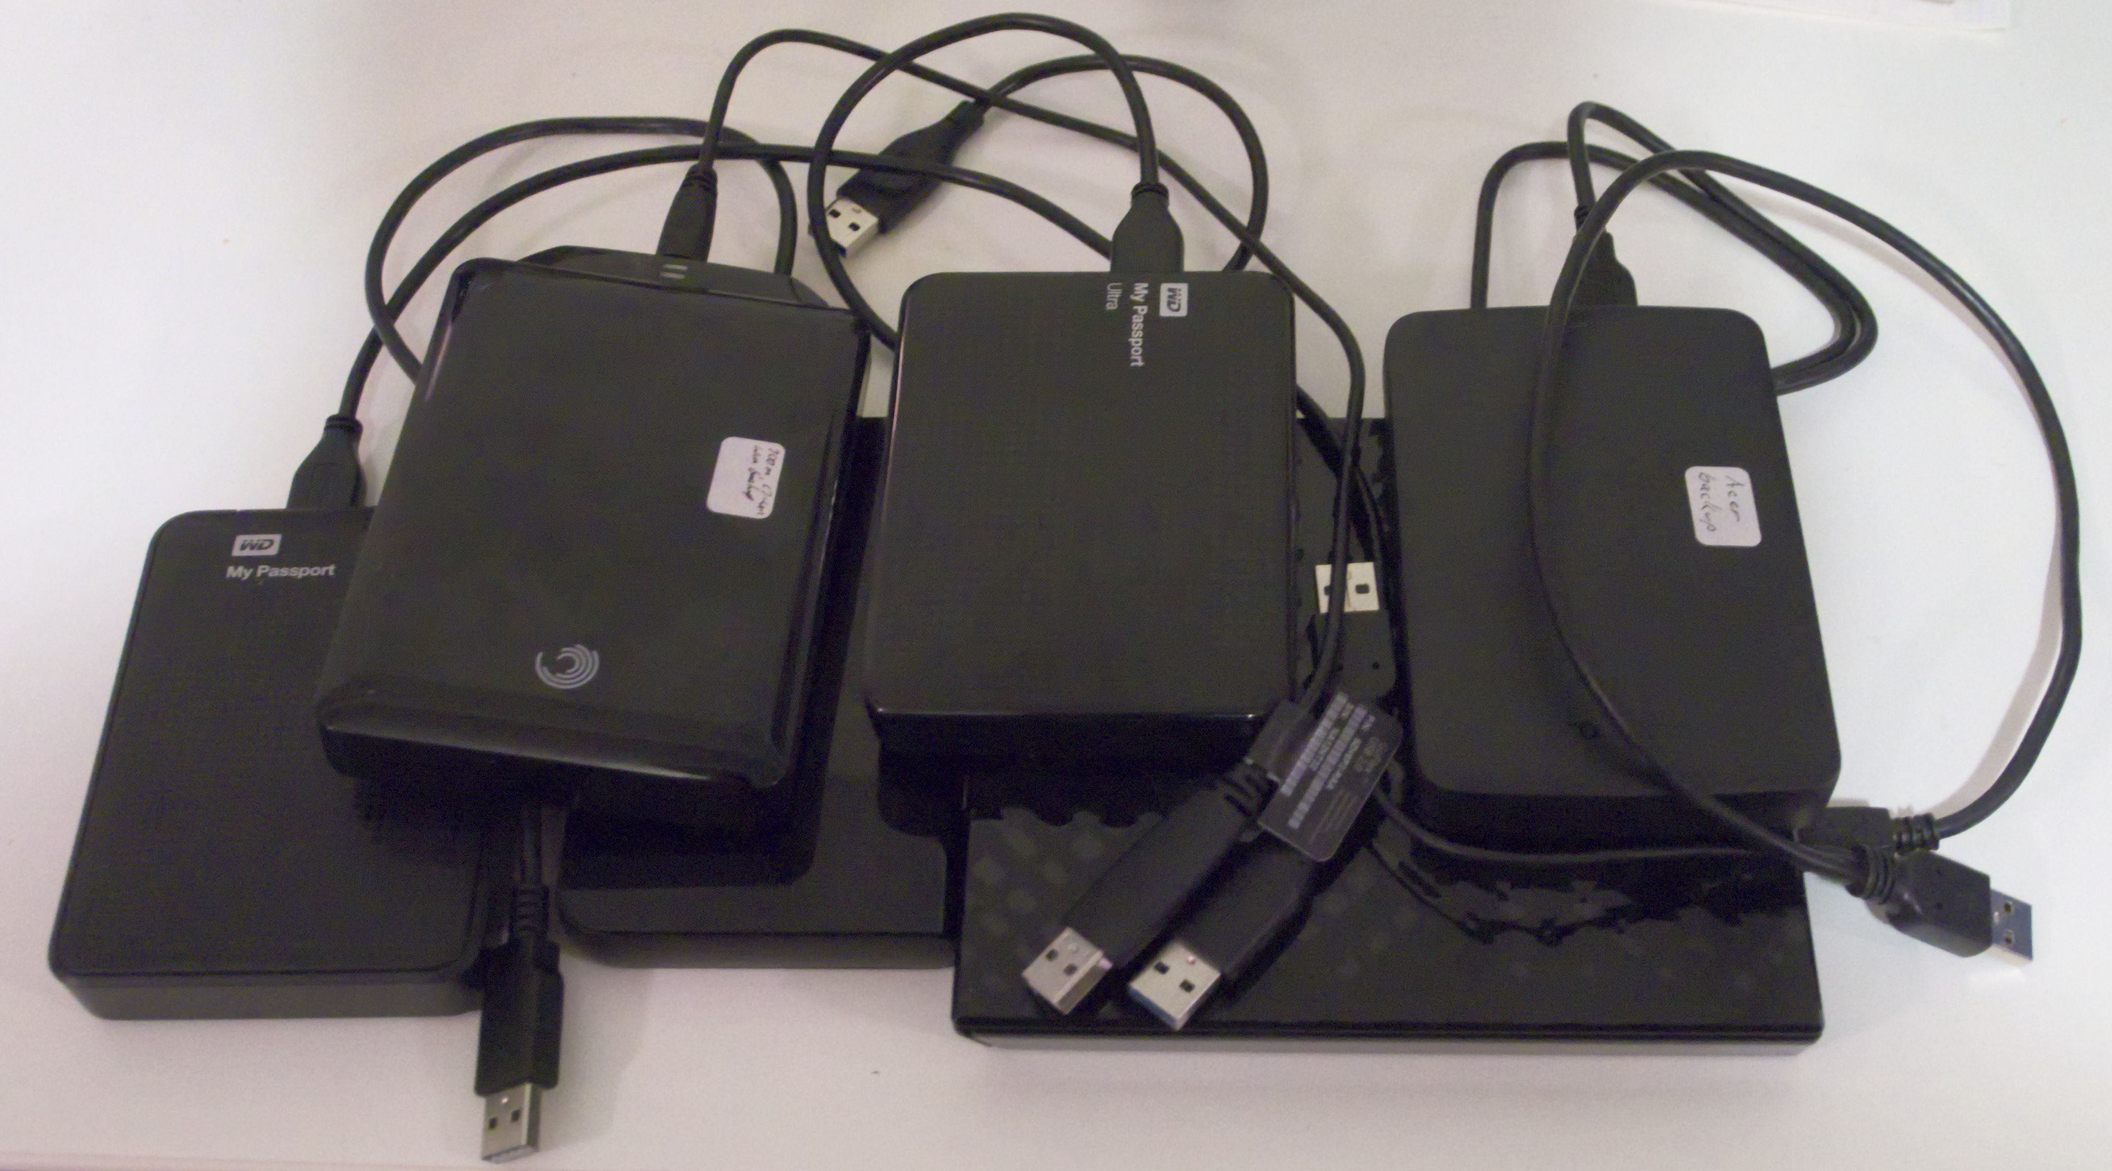

In developing a plan to defend against the loss of data and software from operator, hardware, and software failures and malicious acts, it’s important to take a systematic approach rather than responding to the latest sensational article or alarming ad. Your first step should be to identify the threats. Otherwise, you could end up with a Maginot Line, an expensive defense against an attack that didn't occur and was ineffective against the one that did.

Common threats to PCs and the information they hold include the following:

- Operator errors are common. You mistakenly delete a file, a directory, or an entire partition. If this involves your software, it may disable the PC.
- Software sometimes contains coding errors that create problems, which if serious enough can crash the operating system. Simply repairing the resulting damage doesn't cure the root cause. However, often symptoms appear only under rare conditions, which means you can only repair the damage and hope these don't recur.
- Hardware malfunction often immediately disables the PC, and the solution is to repair the failure and then restore any damaged data. Some problems, such as intermittent RAM failure can be difficult to identify and may require a visit to the shop. Disk failure is common and this requires replacement of the disk and then restoration of the software and data it held.
- Malware is software that is designed to cause damage. Individual programs acquire colorful names, such as virus, ransomware, rootkit, and Trojan horse. Each newly discovered name results in a new commotion, but the remedy is the same for all – remove the malware and then repair the damage. A worry here is that the malware may reside for some time before damage appears, so that you back up the problem as well as your software and when you restore from a backup, you also restore the malware.
- PC loss can occur when traveling with a laptop or when one fails to the extent that repair isn't economically practical. You must replace not only the hardware, but any original equipment manufacturer (OEM) software that is licensed only for the lost machine. You can restore only your data from backup.
- Environmental catastrophe most commonly results from burglary, fire, storm, or flood. Here you lose not only the PC, but perhaps all the material associated with it, including documentation and backup media. At some level, perhaps nuclear holocaust or asteroid strike, you probably decide you don't care as the loss associated with your PC is trivial compared to other damage.

You will surely find that no single approach will protect against all of these, and you may decide to ignore some threats.

You have two software and data repair approaches: reinstall from the original sources or recover from a snapshot of your disk taken previously. Only the latter is possible with data; the receipts needed to recreate your 2012 tax return are long gone, as are the vacation photos on your camera's SD card. However, with software, you have choices:

- Use the original distribution media to create a fresh installation, configure it, and apply any updates for the OS and all the applications. This is tedious, but the result is a clean system, free of whatever problem (assuming it's not with your hardware) that corrupted your system. Most PCs are delivered with the operating system already on the disk and without its installation media; they have instructions on how to create a repair disk, although you may have to dig to find them. Most also have a recovery partition on the disk that you can use to recreate the initial configuration. In my experience, the hard disk is the PC component most likely to fail, which of course makes the recovery partition unavailable. The software supplied with a PC is almost certainly sold as OEM products, which means it is licensed only for that hardware, and it often includes feature to prevent it from being used elsewhere. As a result, you need a separate set of recovery media for each PC, and you need to be able to identify to which hardware each set belongs.
- Recovering the software from a backup is far simpler, because it restores all the software in one step, which has already been configured and updated. However, if the failure was the result of a developing software problem, you also install its root cause. For this reason, many keep backups made at different times, hoping that if they go back far enough, they'll find a clean one. Of course, when you restore an old backup, you most likely also restore your old data, destroying any acquired since. Your recovery plan must include a remedy for this.

There are several choices of backup media:
- a backup directory on your system disk,
- a backup partition on your system disk,
- a separate internal backup hard disk,
- an external backup disk, and
- a cloud service.

Only hard disks and cloud services have the capacity to back up modern disks. Optical media capacities have not kept up with those of hard disks, and far too much of it has poor reliability. Cloud service adds security concerns, both because your data travels over the Internet and because you have entrusted it to an outside entity.

As with the backup medium, you have choices about what to back up. These include:
- a complete disk image,
- all the data files in the home directory, and
- only those data files in the home directory that have changed since the last backup.

Some strategies include backing those OS and application files that have changed, but this can be risky, as these often depend on each other. If you replace a file but not something with which it interacts, the result can be an inoperable system. With software, it's safer to replace everything.

Some backup program developers recommend that your PC have constant access to the backup medium. While this insures that all your data is backed up as soon as its created, it also insures that malware also always has access to the backup. This is a good scheme for protecting against operator error, but less so for protecting against malware and software errors. For the latter, you want your backup medium to be accessible for only very short periods of time. You may decide to use two methods, one that backs up continually to protect against operator error, which are common, and a second that backs up only periodically to protect against such threats as malware.

Backup software is a poor area in which to experiment. Obtain it from well-known vendors with good reputations. Consider only products with favorable reviews from responsible experts. Microsoft includes a suite of recovery software with its operating systems, and you should have a good reason for using something different. I discussed their Windows 7 version of this in the February 2012 issue of BCUG Bytes and the Windows 10 version in the May 2016 issued, available at www.bcug.com. =

After obtaining your choice, test it as best you are able. For a thorough test, you would have to erase your disk and restore a backup, but don't do this. Instead, make a copy of just one file or directory; then backup, delete, and restore it. Compare the original and restored versions. If the recovery software includes a bootable disk, test it on the PC where you will use it to be sure it does boot. This will probably require that you make some changes in your BIOS. Record these before you change them back, as frequently, the BIOS settings must be different for internal disks and external media. You may also wish to obtain and test a reliable repair utility disk. If you suspect a virus infection, you can boot with it and the virus won't be active. This will allow you to copy your data files to an external drive without its interference. I discussed some of these tools in articles in the April, June, July, and August 2012 issues of Bytes.

My strategy is that every week I have a scheduled backup of all the data files that have changed since the previous backup. This is to an internal hard drive, separate from my system and data drives. As a result, I limit my loss from most causes to the data I generate in one week. Once a month, or when I think of it, I back up to an external hard disk, all the data files that have changed since my last external backup. My operating system is Linux, and I have its installation USB memory stick. Almost all my applications are available from the distribution's repositories. As a result, it's convenient to restore all my software as a fresh install, and I do this every two years, even if I have no problems, just to clean out the accumulated cruft. Reviewing this plan against my list of threats, we see the following:

- An operator error can destroy at most a week's work.
- Similarly, most software errors and hardware failure can delete up to weeks of work. Although if one affects both the service and the on-line backup disk, I could lose up to a month's worth, but this is very rare.
- Malware could cost me up to a month, if it affects all the disks. But malware in Linux is uncommon and, so far, I not had this problem.
- Although I do have a laptop, I transfer any data to my desktop as soon as I get home. As a result, losing it would lose only the data acquired on that trip.
- The weak point in my plan is environmental catastrophe, as all my PC gear resides in one room, and I could lose all of it in one incident. I could improve by adding a backup file server to our home network and locating it in the basement or better by storing a backup drive at a neighbor's or in my bank deposit box or using a cloud storage service.

You should make a similar assessment of your backup plan against your own list of threats to see if it needs adjustment.

Your recovery approach of course depends on what is damaged. Your data resides in what is often called the home directory, and this can be restored only from a data backup. However, Windows may store some of your data (such as Internet favorites and e-mail data) in the system area, and recovering them requires a system restore. The operating system and applications reside in what's known as the system area. They can be recovered by restoring a system backup or by making a fresh install from the original distribution media.

If you use Microsoft's backup software, system backups are in the form of full disk images. If your system won't boot, it may be because the boot loader, or in new PCs the UEFI partition, has been damaged. These can be repaired in Windows system using the Windows recovery disk. See the MS Website for instructions. If the BIOS ROM is corrupted, a competent shop may be able to help, but you may have to return the machine its manufacturer.

How you recover depends of course on how you backed up:

- The fastest is to restore from backup as the result will be software that is updated the last version of your data. If this includes restoring the OS, you must be able to boot from live media, which means you have to properly set up your BIOS. Later PCs use UEFI, which adds complexity.
- If you decide to re-install the OS you can try to restore from the PC vendor's recovery partition, which places your computer to its state when you first purchased it. You will have to reinstall all your applications from their distribution disks and your data from a recent backup.
- If the recovery partition isn't available, you'll have to use the OS distribution disk if you purchased it separately or its recovery disks if the OS was installed by the PC vendor. (This of course assumes you created these.)
- As a last resort, if the former isn’t possible or if you doubt your abilities you can take your PC back to the vendor who sold it to you or to an independent shop to have the OS re-installed. You then must restore any applications and your data yourself. It should be clear that record-keeping is a very important component of your plan. In particular, be sure to label your external backup media and any notes. You don’t want to restore from the wrong computer.

Creating and following a good backup discipline require more than trivial knowledge, thought, and time. Many computer owners choose to take a “Do nothing and hope for the best” approach or they follow the advice in the latest article or ad they’ve read, and neither approach is sound. As a last resort, there are commercial firms that will attempt to recover data from damaged or corrupted storage media, but the results aren't certain and the costs are high (up to multiple thousands of dollars).

